Name:
Shadow Height Investigation Planner

What are you going to investigate?

What do you predict will happen? Why?

Variables:
Independent (What I will change):
Dependent (What I will measure or observe):
Controlled (What I will keep the same):

Materials:

Method:

Results:

Distance from torch to glue stick (cm) | Height of shadow (cm)
5
10
15
20
25
30

http://nces.ed.gov/nceskids/createagraph/default.aspx?ID=fa7e1dea08cc4a7bb19f845c57ee6256 link to graph creator and then screen shot your results.
Graph of Results:

Explaining Results:
1. What happened to the height of the shadow when you changed the distance from the torch to the glue stick?

2. Did the result match your prediction? Explain why and how it was different.
Evaluating the Investigation:
1. What challenges did you experience doing this investigation?

2. How did you, or could you, overcome them?

3. How could you improve this? (fairness/accuracy)

Self Reflection: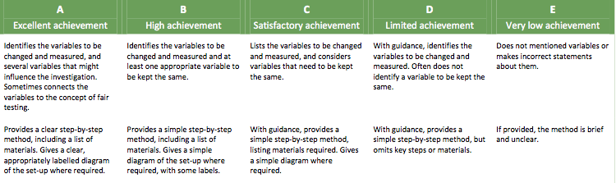
Early finishers: https://www.youtube.com/watch?v=CfLGdj5MXl8

